Renju lesson on July 12, 2001
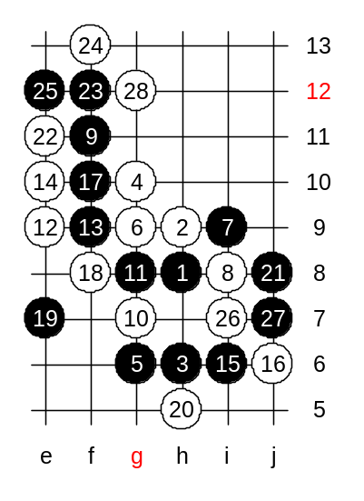
Hello all! Welcome to Online Renju Class. Today we will continue the game teacher vs students that we began last week. Let us set up the position first. This is where we ended the game last week. It is students’ turn now.

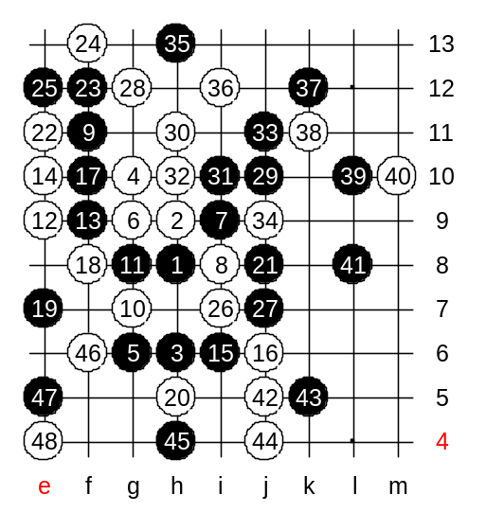
Lets see how much you have studied about this game in past 7 days. We have 13 registered students here now. In case of majority of 7 votes, the move is submitted instantly.

You should make a decision between attack and defense. It is a hard choice. You chose an active move. That is a very brave style. It will make our game very interesting.
It seems our game lasts long. We are not able to finish it today.
Therefore, we will continue it next week. It will be your turn in this game. Please study hard within next 7 days and try to find a good plan for black.

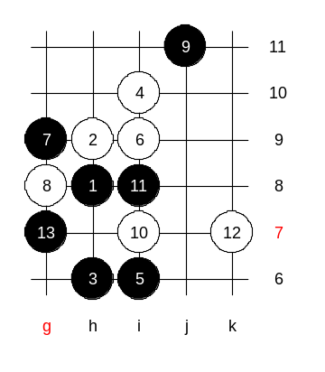
The homework questions are related to new 12th move. However, it does not disclose the true essence of the move.

Medium level homework. Please find the white win.

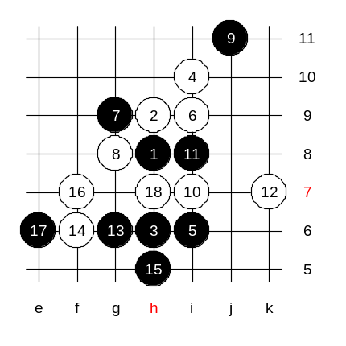

Advanced level homework. Please find the black win.

